|  |  |
| --- | --- |
| **Logo_med2** | **MIMOS BERHAD (336183-H)**  **TECHNOLOGY PARK MALAYSIA,**  **57000 KUALA LUMPUR, MALAYSIA.**  **TEL: + 603 8996 5000**  **FAX: + 603 8996 2755**  **http://www.mimos.my** |

*Measurement System Analysis Tool (MSA)*

|  |  |
| --- | --- |
| Document Id | MSA TOOL - GAGE R&R |
| Revision Number | 0.0.8 |
| Issue Date | 17-Nov-2011 |
| Security Level | Internal |

**This document contains confidential and competition sensitive information. The information contained within should not be reproduced or redistributed without prior written consent from MIMOS BERHAD**

**Revision History**

|  |  |  |  |
| --- | --- | --- | --- |
| Author : | Version : | Date : | Remarks |
| Pavithra | MSA TOOL-Gage R&R -0.0.1 | 15/9/2011 | Initial version |
| Ashok Sivaji, Pavithra | MSA TOOL-Gage R&R -0.0.2 | 28/9/2011 | Proof read, formatting & validation |
| Pavithra | MSA TOOL-Gage R&R -0.0.3 | 05/10/2011 | Proof read, formatting & validation |
| Pavithra | MSA TOOL-Gage R&R -0.0.4 | 12/10/2011 | Proof read, formatting & validation |
| Pavithra | MSA TOOL-Gage R&R -0.0.5 | 19/10/2011 | Proof read, formatting & validation |
| Pavithra | MSA TOOL-Gage R&R -0.0.6 | 02/11/2011 | Proof read, formatting & validation |
| Pavithra | MSA TOOL-Gage R&R -0.0.7 | 09/11/2011 | Proof read, formatting & validation |
| Pavithra | MSA TOOL-Gage R&R -0.0.8 | 17/11/2011 | Proof read, formatting & validation |

Table of Contents

[1. Requirements 6](#_Toc308013278)

[1.1. GRR 6](#_Toc308013279)

[2. Developer Guide 15](#_Toc308013280)

[2.1. Software / Language 15](#_Toc308013281)

[2.2. Database 15](#_Toc308013282)

[3. Status of completion for the Gage R & R 15](#_Toc308013283)

[Table 1: Status of Completion for the Gage R&R (Static table) 16](#_Toc308013284)

[Table 2: Status of Completion for the Gage R&R (Dynamic table) 17](#_Toc308013285)

[4. User Guide: Steps to create Gage R&R 18](#_Toc308013286)

[Table 3: Steps to create Gage R&R 19](#_Toc308013287)

[5. References 20](#_Toc308013288)

[[1] Atul Khandekar,” AIAG's MSA (Measurement Systems Analysis) 3rd Edition K1,K2, K3”, http://elsmar.com/Forums/showthread.php?t=6066 20](#_Toc308013289)

[[2]20110131,”R&R or Gauge R&R Repeatability and Reproducibility”, http://www.sixsigmaspc.com/dictionary/RandR-repeatability-reproducibility.html 20](#_Toc308013290)

[[3]MedCalc Software,Version 11.6.1, “Control Chart – MedCalc”, http://www.medcalc.org/manual/control\_chart.php 20](#_Toc308013291)

[[4]MoreSteam.com LLC 2011 “Measurement System Analysis”,www.moresteam.com/toolbox/t403.cfm 20](#_Toc308013292)

[[5] Advance Software Engineer 2009,“Multi-Platform Chart Component and Control Library”,www.advsofteng.com/product.html 20](#_Toc308013293)

[[6]Williamliu93,”Create Navigation bar using PHP,CSS, and Dreamweaver”, http://www.youtube.com/watch?v=habZHcnShfs 20](#_Toc308013294)

[[7]Adam,”Active Page Link Tutorial for your Website Menu: CSS PHP Dreamweaver”,http://www.youtube.com/watch?v=XoUvVzMm0rg 20](#_Toc308013295)

[[8]Big Resource 2005-08, http://php.bigresource.com/Calculate-average-number-from-a-group-of-numbers--JfVdCsvU.html 20](#_Toc308013296)

[[9]PHP Maths Functions, http://www.w3schools.com/php/php\_ref\_math.asp 20](#_Toc308013297)

[[10]Freeware GRR Calculator:: Symphony Technologies:, http://www.symphonytech.com/grrfree.htm 20](#_Toc308013298)

[[11]Measurement Systems Analysis/Gage R&R BPI Consulting LLC2010, http://www.spcforexcel.com/msa-and-spc-for-excel?gclid=CIDBlY- J7qoCFYkc6wodbT0VOg 20](#_Toc308013299)

[[12] sixsigmamoneybelt,”What is MSA (Measurement System Analysis)”,http://www.youtube.com/watch?v=gj0z4inhFv8&NR=1 20](#_Toc308013300)

[[13] QI Macros,”Gage R&R Analysis in excel”, http://www.youtube.com/watch?v=R92xVbogF6g&feature=related 21](#_Toc308013301)

[[14]Promontory Management Group, Inc,”Gauge Repeatability and Reproducability”, http://www.youtube.com/watch?v=DgVBhozylT4 21](#_Toc308013302)

Table of Figures

[Figure 1: GRR Flowchart 7](#_Toc304980937)

[Figure 2: GRR Formula/ Algorithm Flow 9](#_Toc304980938)

[Figure 3: Database Schema 10](#_Toc304980939)

[Figure 4: Interface Presentation 13](#_Toc304980940)

[Figure 5: Interface Interaction 14](#_Toc304980941)

Table of Tables

[Table 1: Status of Completion for the Gage R&R (Static table) 16](#_Toc305654348)

[Table 2: Status of Completion for the Gage R&R (Dynamic table) 17](#_Toc305654349)

[Table 3: Steps to create Gage R&R 19](#_Toc305654350)

# Requirements

This section specified the requirements for the Measurement System Analysis (MSA) tools being developed. The MSA consist of GRR, Bias and Linearity. The Phase 1 of this project is to develop the GRR.

## GRR

User Requirement

|  |  |  |
| --- | --- | --- |
| **What** | **When** | **Status** |
| GRR Formula / Algorithm Development | 12 -September | 100%, See View Flow Chart, Figure 1 & 2 |
| Develop Database Schema   * Input data into db * Output data into report * Create table from DB * Requirement * Measurement * Performance Metrics * Reporting |  | 100% Figure 3 |
| Develop Interface Presentation |  | 80% Figure 4 |
| Develop Interface Interaction   * Requirement * Measurement * Performance Metrics * Reporting |  | 15% Figure 5 |
| Develop Reporting Module |  | 80% Figure 4 |
| Develop Validation   * Requirement * Measurement * Performance Metrics * Reporting |  |  |

Figure 1: GRR Flowchart

**Home**

Main page of the web. It contains the overview of Measurement Analysis Tool, Gage R&R.

**Requirement**

The second page of the web. Users have to insert required preliminary data to proceed to the next page. User can also view the saved data by selecting the gage name here, and the table will be generated.

**Measurement**

Third page of the web. Users have to insert data to the table. The calculation will be done once the user click “Calculate”. The calculation done here is the base formula required to calculate Gage R&R in the next page which is ***Metrics***. The formulas are Xa, Xb, Xc, Ra, Rb. Rc, X and Sum.

**Metrics**

Calculation of R(d-bar), UCLR, Rp, X Diff, UCL, LCL, EV, AV, R&R, PV, TV, %EV, %AV, %R&R, %PV and ‘npc will be done here. The required data will be sent to the next page, which is ***Reporting***, to generate graph.

**Reporting**

Graph will be generated here based on the data from the ***Metrics***. The acceptance rate will be shown here.

**Help**

User guidance will be provided here.

Figure 2: GRR Formula/ Algorithm Flow



Figure 3: Database Schema



**Home Page**

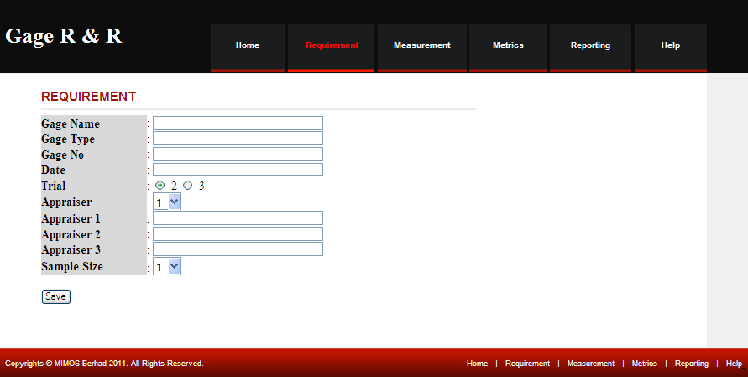

**Requirement**

**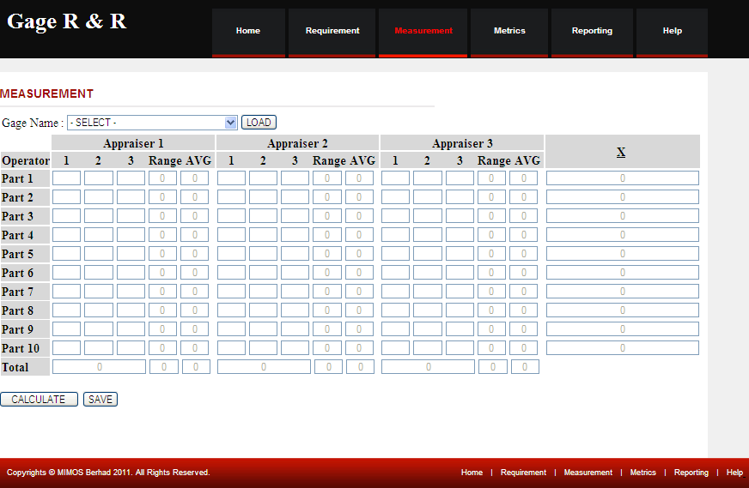**

**Measurement**

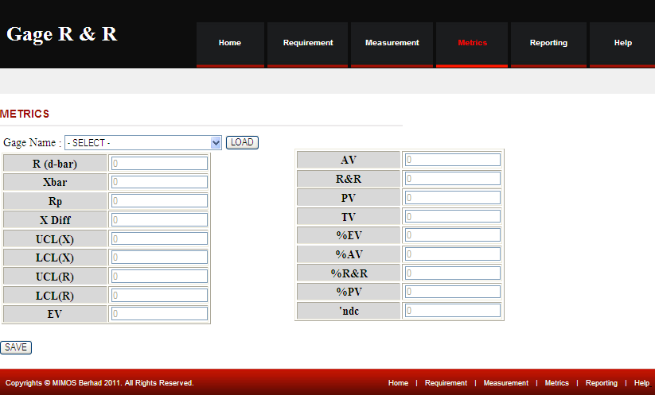

**Metrics**

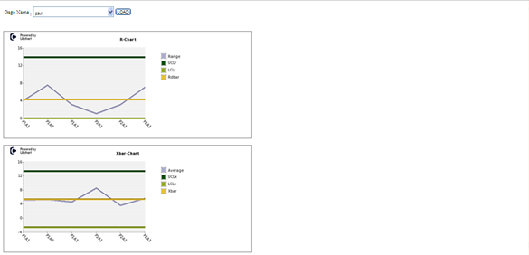

**Reporting(in progress to insert into template)**

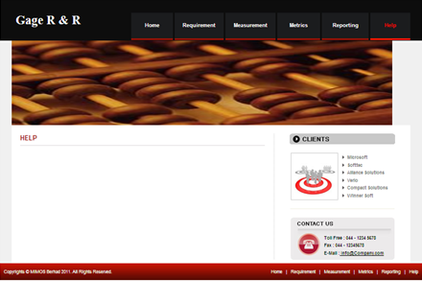

**Help(in progress)**

Figure 4: Interface Presentation

Figure 5: Interface Interaction

# Developer Guide

## Software / Language

* + 1. PHP version 5.3.5
    2. Adobe Dreamweaver CS5.5

## Database

* + 1. SQL Yog

# Status of completion for the Gage R & R

|  |  |  |  |  |
| --- | --- | --- | --- | --- |
| **No.** | **How To** | **Using SQLyog** | **Using PHP** | **Status** |
|  | Create webpage using template |  |  | 14 – Sep – 2011 |
|  | Create menu bar |  |  | 14 – Sep – 2011 |
|  | Create form-preliminary data |  |  | 08 – Sep - 2011 |
|  | Create tables |  |  | 09 – Sep - 2011 |
|  | Create table |  |  | 12 – Sep - 2011 |
|  | Insert formula in table (webpage) |  |  | 12 – Sep - 2011 |
|  | Insert formula in coding |  |  |  |
|  | Do validation |  |  |  |
|  | Connect to the database |  |  |  |
|  | Function - calculate Sum |  |  | 21 – Sep - 2011 |
|  | Function - calculate Range |  |  | 22 – Sep - 2011 |
|  | Function - calculate Average |  |  | 21 – Sep - 2011 |
|  | Function - calculate Mean |  |  | 20 – Sep - 2011 |
|  | Function - calculate Ra,Rb,Rc |  |  | 21 – Sep - 2011 |
|  | Function - calculate Rp |  |  |  |
|  | Function - calculate R(d-bar) |  |  |  |
|  | Function - calculate UCLR |  |  |  |
|  | Function - calculate Max X |  |  |  |
|  | Function - calculate Min X |  |  |  |
|  | Function - calculate X Diff |  |  |  |
|  | Function - calculate EV |  |  |  |
|  | Function - calculate AV |  |  |  |
|  | Function - calculate R&R |  |  |  |
|  | Function - calculate PV |  |  |  |
|  | Function - calculate TV |  |  |  |
|  | Function - calculate %EV |  |  |  |
|  | Function - calculate %AV |  |  |  |
|  | Function - calculate %R&R |  |  |  |
|  | Function - calculate %PV |  |  |  |
|  | Function - calculate %TV |  |  |  |
|  | Function - calculate TV |  |  |  |
|  | Generate graph in php |  |  |  |

Checked Validation

##### Table 1: Status of Completion for the Gage R&R (Static table)

|  |  |  |  |  |
| --- | --- | --- | --- | --- |
| **No.** | **How To** | **Using SQLyog** | **Using PHP** | **Status** |
|  | Create webpage using template |  |  | 14 – Sep – 2011 |
|  | Create menu bar |  |  | 14 – Sep – 2011 |
|  | Create form-preliminary data |  |  | 08 – Sep - 2011 |
|  | Create table |  |  | 03 – Oct - 2011 |
|  | Insert formula in table (webpage) |  |  | 04 – Oct - 2011 |
|  | Insert formula in coding |  |  | 04 – Oct - 2011 |
|  | Do validation |  |  |  |
|  | Connect to the database |  |  | 07 – Oct - 2011 |
|  | Function - calculate Sum |  |  | 10 – Oct - 2011 |
|  | Function - calculate Range |  |  | 04 – Oct - 2011 |
|  | Function - calculate Average |  |  | 04 – Oct - 2011 |
|  | Function - calculate Mean |  |  | 05 – Oct - 2011 |
|  | Function - calculate Ra,Rb,Rc |  |  | 11 – Oct - 2011 |
|  | Function - calculate Xa, Xb, Xc |  |  | 11 – Oct - 2011 |
|  | Function - calculate Rp |  |  | 14 – Oct - 2011 |
|  | Function - calculate R(d-bar) |  |  | 14 – Oct - 2011 |
|  | Function - calculate UCLR |  |  | 14 – Oct - 2011 |
|  | Function - calculate Max X |  |  | 14 – Oct - 2011 |
|  | Function - calculate Min X |  |  | 14 – Oct - 2011 |
|  | Function - calculate X Diff |  |  | 14 – Oct - 2011 |
|  | Function - calculate EV |  |  | 17 – Oct - 2011 |
|  | Function - calculate AV |  |  | 17 – Oct - 2011 |
|  | Function - calculate R&R |  |  | 17 – Oct - 2011 |
|  | Function - calculate PV |  |  | 17 – Oct - 2011 |
|  | Function - calculate TV |  |  | 17 – Oct - 2011 |
|  | Function - calculate %EV |  |  | 17 – Oct - 2011 |
|  | Function - calculate %AV |  |  | 17 – Oct - 2011 |
|  | Function - calculate %R&R |  |  | 17 – Oct - 2011 |
|  | Function - calculate %PV |  |  | 17 – Oct - 2011 |
|  | Function - calculate %TV |  |  | 17 – Oct - 2011 |
|  | Function - calculate TV |  |  | 17 – Oct - 2011 |
|  | Pull data from database |  |  |  |
|  | Generate graph in php |  |  |  |

##### Table 2: Status of Completion for the Gage R&R (Dynamic table)

# User Guide: Steps to create Gage R&R

|  |  |  |
| --- | --- | --- |
| **No.** | **How To** | **Step by Step** |
|  | Create webpage using template | Find suitable template and edit |
|  | Create menu bar | Edit the menu bar in the template |
|  | Create form-preliminary data | Create table  Create text field  Create radio button  Create Select(list/menu) form  Create button |
|  | Create tables | Create database in SQLyog  Create table in the database |
|  | Create table | Create table for insert data in page ‘Requirement’  Create table for insert data in page ‘Measurement’  Create table for insert data in page ‘Metrics’ |
|  | Insert formula in table (webpage) | Insert the formula to the table in page ‘Metrics’ |
|  | Insert formula in coding |  |
|  | Do validation |  |
|  | Connect to the database |  |
|  | Function - calculate Sum |  |
|  | Function - calculate Range |  |
|  | Function - calculate Average |  |
|  | Function - calculate Mean |  |
|  | Function - calculate Ra,Rb,Rc |  |
|  | Function - calculate Rp |  |
|  | Function - calculate R(d-bar) |  |
|  | Function - calculate UCLR |  |
|  | Function - calculate Max X |  |
|  | Function - calculate Min X |  |
|  | Function - calculate X Diff |  |
|  | Function - calculate EV |  |
|  | Function - calculate AV |  |
|  | Function - calculate R&R |  |
|  | Function - calculate PV |  |
|  | Function - calculate TV |  |
|  | Function - calculate %EV |  |
|  | Function - calculate %AV |  |
|  | Function - calculate %R&R |  |
|  | Function - calculate %PV |  |
|  | Function - calculate %TV |  |
|  | Function - calculate TV |  |
|  | Generate graph in php |  |
|  | Create webpage using template |  |
|  | Create menu bar |  |
|  | Create tables |  |

##### Table 3: Steps to create Gage R&R

# References

### [1] Atul Khandekar,” AIAG's MSA (Measurement Systems Analysis) 3rd Edition K1,K2, K3”, <http://elsmar.com/Forums/showthread.php?t=6066>

### [2]20110131,”R&R or Gauge R&R Repeatability and Reproducibility”, <http://www.sixsigmaspc.com/dictionary/RandR-repeatability-reproducibility.html>

### [3]MedCalc Software,Version 11.6.1, “Control Chart – MedCalc”, <http://www.medcalc.org/manual/control_chart.php>

### [4]MoreSteam.com LLC 2011 “Measurement System Analysis”,[www.moresteam.com/toolbox/t403.cfm](http://www.moresteam.com/toolbox/t403.cfm)

### [5] Advance Software Engineer 2009,“Multi-Platform Chart Component and Control Library”,[www.advsofteng.com/product.html](http://www.advsofteng.com/product.html)

### [6]Williamliu93,”Create Navigation bar using PHP,CSS, and Dreamweaver”, <http://www.youtube.com/watch?v=habZHcnShfs>

### [7]Adam,”Active Page Link Tutorial for your Website Menu: CSS PHP Dreamweaver”,<http://www.youtube.com/watch?v=XoUvVzMm0rg>

### [8]Big Resource 2005-08, <http://php.bigresource.com/Calculate-average-number-from-a-group-of-numbers--JfVdCsvU.html>

### [9]PHP Maths Functions, <http://www.w3schools.com/php/php_ref_math.asp>

### [10]Freeware GRR Calculator:: Symphony Technologies:, <http://www.symphonytech.com/grrfree.htm>

### [11]Measurement Systems Analysis/Gage R&R BPI Consulting LLC2010, [http://www.spcforexcel.com/msa-and-spc-for-excel?gclid=CIDBlY- J7qoCFYkc6wodbT0VOg](http://www.spcforexcel.com/msa-and-spc-for-excel?gclid=CIDBlY-%20%20%20J7qoCFYkc6wodbT0VOg)

### [12] sixsigmamoneybelt,”What is MSA (Measurement System Analysis)”,<http://www.youtube.com/watch?v=gj0z4inhFv8&NR=1>

### [13] QI Macros,”Gage R&R Analysis in excel”, <http://www.youtube.com/watch?v=R92xVbogF6g&feature=related>

### **[14]**Promontory Management Group, Inc,”Gauge Repeatability and Reproducability”, <http://www.youtube.com/watch?v=DgVBhozylT4>